Contact Details:-
Mob.-+91-9426349498 SHUKAN N. VYAS
Career Objective:
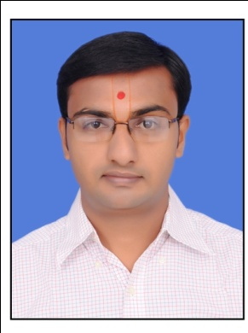
Email-shukan059@gmail.com
To enthusiastically work for the organization for its development and enhance my own skill and knowledge.

Work Experience :
- Currently working as an Electrical Design Engineer in Pima Controls PVT LTD.
- As an Electrical Design Draftsman from 1 march 2017 to 31 may 2017 in electrical department in at AMBA TOWNSHIP PVT LTD.
- As a skilled employee in GIS department at Torrent Power on contractual basic with Rajesh Power Services Pvt. Ltd. From 19 March 2015 to 28 February 2017.
- As a junior Electrical Engineer in Narnarayan Electricals from 15 June 2014 to 15 March 2015.

WORK RESPONSIBILITY:
- As per customer requirement prepare G.A drawing of panel.
- To prepare power wiring diagram of panel.
- To prepare control wiring diagram of panel.
- To prepare of bills of materials(BOM) of panel.
COMPUTER SKILLS:
- REVIT MEP 2016 FROM KHODIYAR CAD

- AUTOCAD(2D + 3D DRAFTTING)

- INTERNET

- MS OFFICE
- C&C++ ,LANGUAGE etc.
EDUCATIONAL QUALIFICATION:
DEGREE/ CERTIFICATE | YEAR OF PASSING | SCHOOL/ COLLEGE | BOARD/UNIVERSITY | MARKS OBTAINED
B.E.(Electrical) | 2014 | AHMEDABAD INSTITUTE OF TECHNOLOGY | GTU | 6.40 CGPA
H.S.C | 2008 | Abhijat Vidyavihar | GSCB | 48%
S.S.C | 2006 | Balprasoon Vidyalaya | GSCB | 80.43%

AREA OF EXPERTISE:

A competent electrical engineer with a comprehensive knowledge of designing,
Developing and maintaining electrical systems and components to required
Specifications, focusing on economy, safety, reliability, quality and sustainability

Career Statement:
“I feel that my strongest strengths are firstly having a passion for electrical engineering. Secondly an ability to understand and prioritize my work in a changing business environment, thereby helping me to successfully deliver results. Finally my practice of consulting with all parties involved in a project, then identifying the requirements and to then provide an appropriate solution.”

Personal profile:
Name : Shukan Vyas
Father’s Name : Nareshkumar Vyas
Sex : Male
Date of Birth : 30-10-1990
Marital Status : Single
Nationality : Indian
Language Known : Hindi, English, Gujarati
Hobbies : Listening music, Traveling, Reading.
Permanent Address : 11, Gopinath Society,B/h Shriji Towers, Opp Drive-in Cinema, Ahmedabad- 380052.
DECLARATION:
I hereby declare that the above-mentioned information is correct up to my knowledge and I bear the responsibility for the correctness of the above mentioned particulars.
Shukan N Vyas

